Lab - Using Windows PowerShell

# Objectives

The objective of the lab is to explore some of the functions of PowerShell.

Part 1: Access PowerShell console.

Part 2: Explore Command Prompt and PowerShell commands.

Part 3: Explore cmdlets.

Part 4: Explore the netstat command using PowerShell.

Part 5: Empty recycle bin using PowerShell.

# Background

PowerShell is a powerful automation tool. It is both a command console and a scripting language. In this lab, you will use the console to execute some of the commands that are available in both the command prompt and PowerShell. PowerShell also has functions that can create scripts to automate tasks and work together with the Windows Operating System.

# Required Resources

* 1 Windows PC with PowerShell installed and internet access

# Instructions

## Access PowerShell console.

* + 1. Click **Start**. Search and select **powershell**.

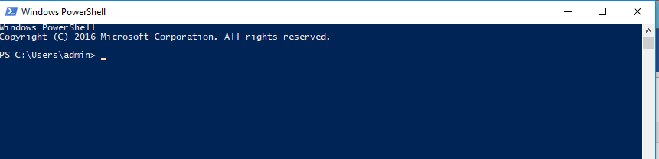

* + 1. Click **Start**. Search and select **command prompt**.

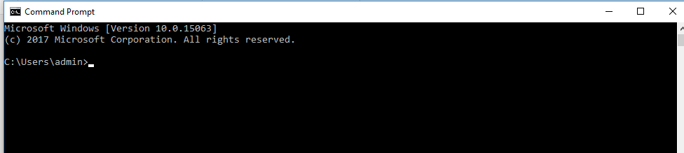

## Explore Command Prompt and PowerShell commands.

* + 1. Enter **dir** at the prompt in both windows.

### Question:

What are the outputs to the **dir** command?

Both windows provide a list of subdirectories and files, and associated information like type, file size, date and time of last write. In PowerShell, the attributes/modes are also shown.

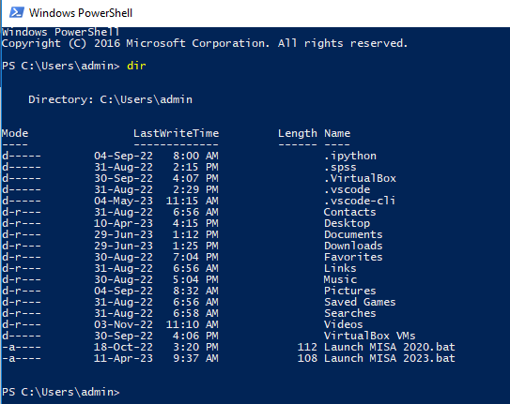

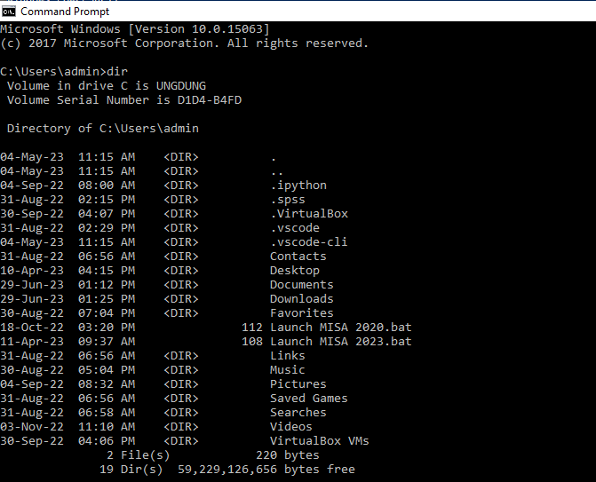

Type your answers here.

* + 1. Try another command that you have used in the command prompt, such as **ping**, **cd**, and **ipconfig**.

### Question:

What are the results?  
The output in both windows are similar.

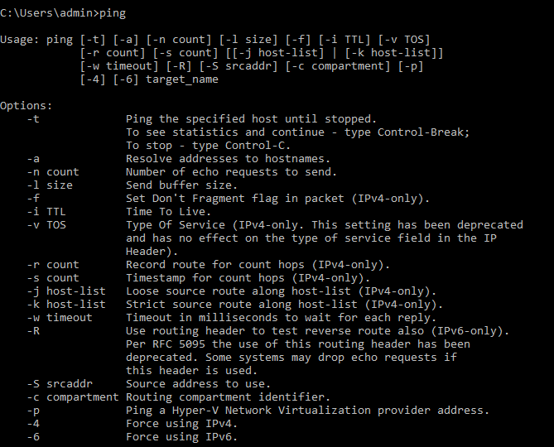



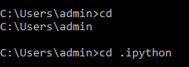

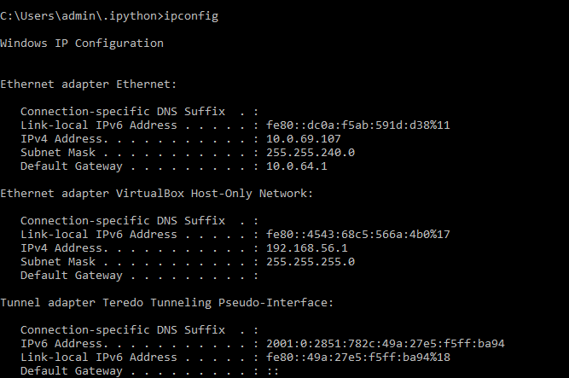

Type your answers here.

## Explore cmdlets.

* + 1. PowerShell commands, cmdlets, are constructed in the form of *verb-noun* string. To identify the PowerShell command to list the subdirectories and files in a directory, enter **Get-Alias dir** at the PowerShell prompt.

PS C:\Users\CyberOpsUser> **Get-Alias dir**

CommandTypeNameVersionSource

----------------------------

Aliasdir -> Get-ChildItem

### Question:

What is the PowerShell command for **dir**?

Get-ChildItem

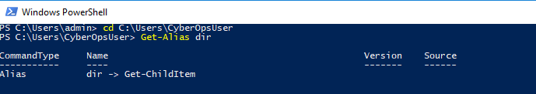

Type your answers here.

* + 1. For more detailed information about cmdlets, perform an internet search for **Microsoft powershell cmdlets**.

For more detailed information about cmdlets:

<https://learn.microsoft.com/en-us/powershell/scripting/how-to-use-docs?view=powershell-7.3>

* + 1. Close the Command Prompt window when done.

## Explore the netstat command using PowerShell.

* + 1. At the PowerShell prompt, enter **netstat -h** to see the options available for the **netstat** command.

PS C:\Users\CyberOpsUser> **netstat -h**

Displays protocol statistics and current TCP/IP network connections.

NETSTAT [-a] [-b] [-e] [-f] [-n] [-o] [-p proto] [-r] [-s] [-x] [-t] [interval]

-a Displays all connections and listening ports.

-b Displays the executable involved in creating each connection or listening port. In some cases well-known executables host multiple independent components, and in these cases the sequence of components involved in creating the connection or listening port is displayed. In this case the executable name is in [] at the bottom, on top is the component it called, and so forth until TCP/IP was reached. Note that this option can be time-consuming and will fail unless you have sufficient permissions.

<some output omitted>

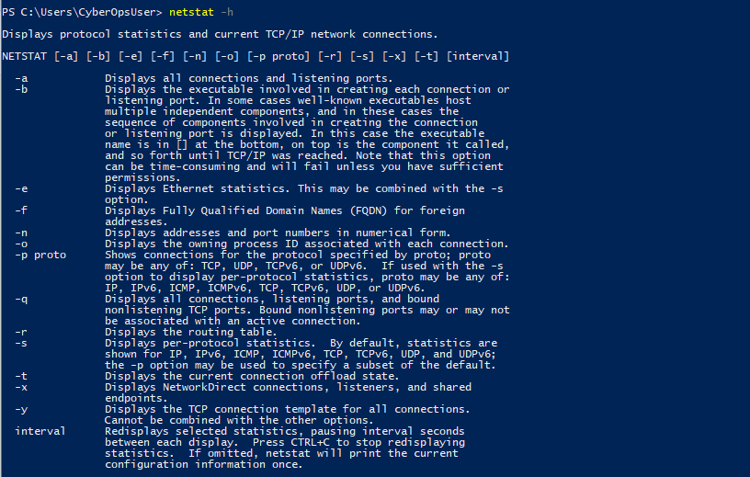

* + 1. To display the routing table with the active routes, enter **netstat -r** at the prompt.

PS C:\Users\CyberOpsUser> **netstat -r**

===========================================================================

Interface List

3...08 00 27 a0 c3 53 ......Intel(R) PRO/1000 MT Desktop Adapter

10...08 00 27 26 c1 78 ......Intel(R) PRO/1000 MT Desktop Adapter #2

1...........................Software Loopback Interface 1

===========================================================================

IPv4 Route Table

===========================================================================

Active Routes:

Network Destination Netmask Gateway Interface Metric

0.0.0.0 0.0.0.0 192.168.1.1 192.168.1.5 25

127.0.0.0 255.0.0.0 On-link 127.0.0.1 331

127.0.0.1 255.255.255.255 On-link 127.0.0.1 331

127.255.255.255 255.255.255.255 On-link 127.0.0.1 331

169.254.0.0 255.255.0.0 On-link 169.254.181.151 281

169.254.181.151 255.255.255.255 On-link 169.254.181.151 281

169.254.255.255 255.255.255.255 On-link 169.254.181.151 281

192.168.1.0 255.255.255.0 On-link 192.168.1.5 281

192.168.1.5 255.255.255.255 On-link 192.168.1.5 281

192.168.1.255 255.255.255.255 On-link 192.168.1.5 281

224.0.0.0 240.0.0.0 On-link 127.0.0.1 331

224.0.0.0 240.0.0.0 On-link 192.168.1.5 281

224.0.0.0 240.0.0.0 On-link 169.254.181.151 281

255.255.255.255 255.255.255.255 On-link 127.0.0.1 331

255.255.255.255 255.255.255.255 On-link 192.168.1.5 281

255.255.255.255 255.255.255.255 On-link 169.254.181.151 281

===========================================================================

Persistent Routes:

None

IPv6 Route Table

===========================================================================

Active Routes:

If Metric Network Destination Gateway

1 331 ::1/128 On-link

3 281 fe80::/64 On-link

10 281 fe80::/64 On-link

10 281 fe80::408b:14a4:7b64:b597/128

On-link

3 281 fe80::dd67:9e98:9ce0:51e/128

On-link

1 331 ff00::/8 On-link

3 281 ff00::/8 On-link

10 281 ff00::/8 On-link

===========================================================================

Persistent Routes:

None

### Question:

What is the IPv4 gateway?

The gateway is 10.0.64.1

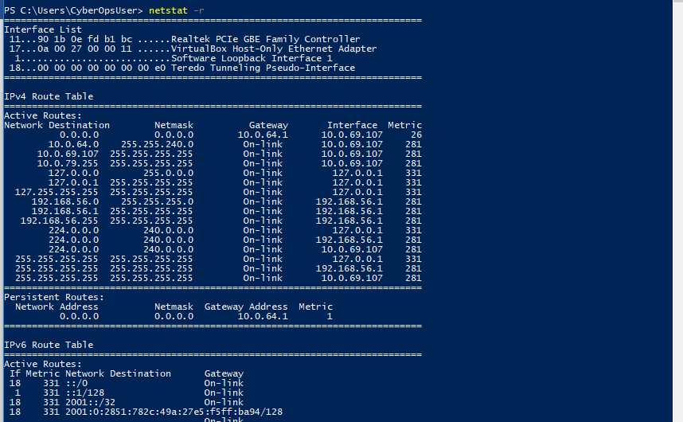 e your answers here.

* + 1. Open and run a second PowerShell with elevated privileges. Click **Start**. Search for PowerShell and right-click **Windows PowerShell** and select **Run as administrator**. Click **Yes** to allow this app to make changes to your device.

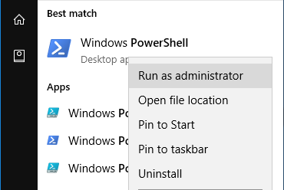



* + 1. The netstat command can also display the processes associated with the active TCP connections. Enter the **netstat -abno** at the prompt.

PS C:\Windows\system32> **netstat -abno**

Active Connections

Proto Local Address Foreign Address State PID

TCP 0.0.0.0:135 0.0.0.0:0 LISTENING 756

RpcSs

[svchost.exe]

TCP 0.0.0.0:445 0.0.0.0:0 LISTENING 4

Can not obtain ownership information

TCP 0.0.0.0:49664 0.0.0.0:0 LISTENING 444

Can not obtain ownership information

TCP 0.0.0.0:49665 0.0.0.0:0 LISTENING 440

Schedule

[svchost.exe]

TCP 0.0.0.0:49666 0.0.0.0:0 LISTENING 304

EventLog

[svchost.exe]

TCP 0.0.0.0:49667 0.0.0.0:0 LISTENING 1856

[spoolsv.exe]

TCP 0.0.0.0:49668 0.0.0.0:0 LISTENING 544

<some output omitted>

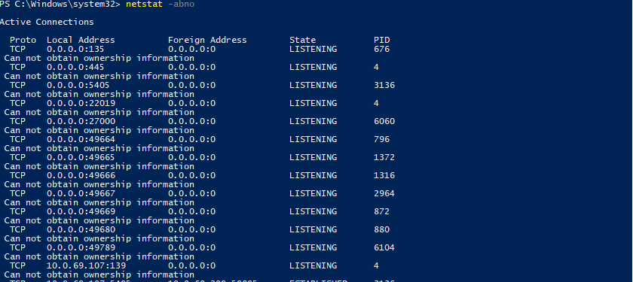

* + 1. Open the Task Manager. Navigate to the **Details** tab. Click the **PID** heading so the PID are in order.

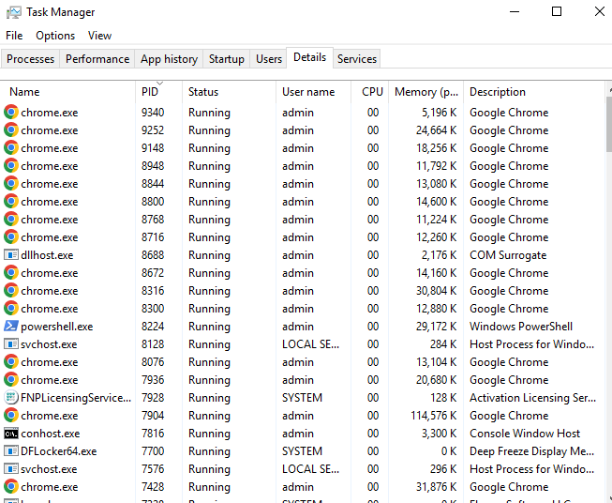

* + 1. Select one of the PIDs from the results of netstat -abno. PID 756 is used in this example.
    2. Locate the selected PID in the Task Manager. Right-click the selected PID in the Task Manager to open the **Properties** dialog box for more information.

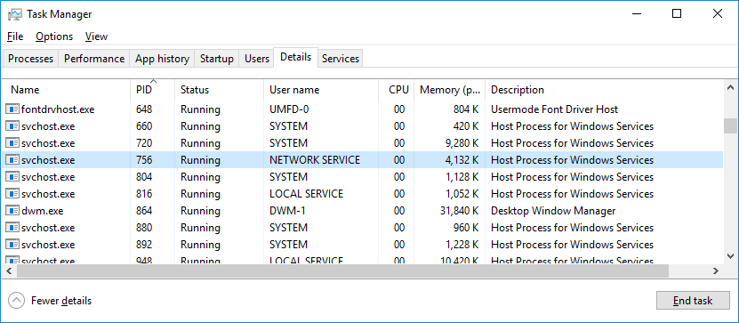

### Question:

What information can you get from the Details tab and the Properties dialog box for your selected PID?



PID 676 is associated with svchost.exe process. The user for this process is NETWORK SERVICE and it is using 3080K of memory. here.

## Empty recycle bin using PowerShell.

PowerShell commands can simplify management of a large computer network. For example, if you wanted to implement a new security solution on all servers in the network you could use a PowerShell command or script to implement and verify that the services are running. You can also run PowerShell commands to simplify actions that would take multiple steps to execute using Windows graphical desktop tools.

* + 1. Open the Recycle Bin. Verify that there are items that can be deleted permanently from your PC. If not, restore those files.
    2. If there are no files in the Recycle Bin, create a few files, such as text file using Notepad, and place them into the Recycle Bin.
    3. In a PowerShell console, enter **clear-recyclebin** at the prompt.

PS C:\Users\CyberOpsUser> **clear-recyclebin**

Confirm

Are you sure you want to perform this action?

Performing the operation "Clear-RecycleBin" on target "All of the contents of the Recycle Bin".

[Y] Yes [A] Yes to All [N] No [L] No to All [S] Suspend [?] Help (default is "Y"): y

### Question:

What happened to the files in the Recycle Bin?

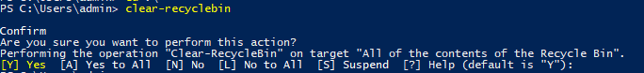

The files in the Recycle Bin are deleted permanently.our answers here.

# Reflection Question

PowerShell was developed for task automation and configuration management. Using the internet, research commands that you could use to simplify your tasks as a security analyst. Record your findings.



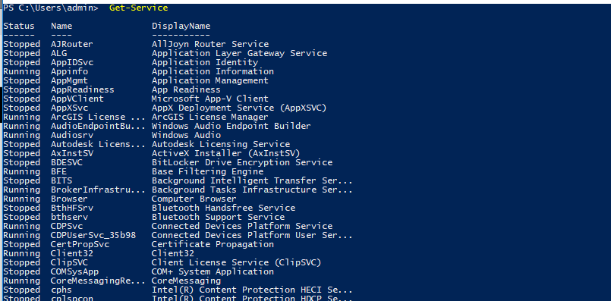

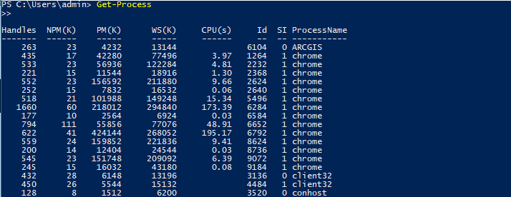

Type your answers here.

End of document